FINAL EXAMINATION
TIME ALLOWED: 90’
Subject: Linear Algebra. No books allowed.

1/ Determine all real value(s) m such that the matrix 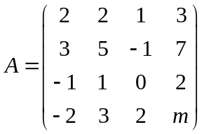 is invertible.

2/ Find the matrix  such that 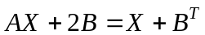, where 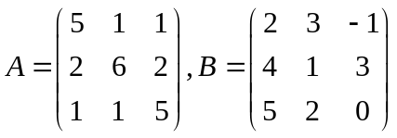
3/ Given an inner product in 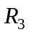 as follow:
.
Find the length of the vector 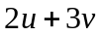, where 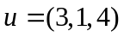 and 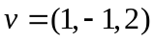.

4/ Let 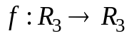 be the linear transformation. Given that .
For all 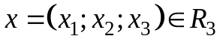, compute 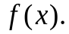

5/ Let be the linear transformation. Compute 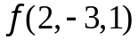 , given that
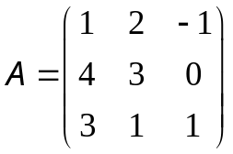 is the matrix of 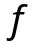with respect to the basic 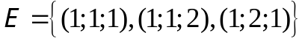.
6/ Compute 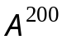, given that 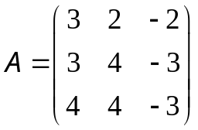.

7/ Make a change of variables that transforms the quadratic form
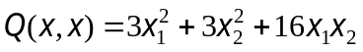 into the canonic form (using the orthogonal diagonalization method).

-----------------------  -----------------------

